AIML Project Data Visualization
Title of the Project:
Personal Data Breach Alert System
Name: Y. SRI ANJANA(2420030204)
Name:Suresh.K(2420030229)
Name:Srihithreddy Kunta(2420030248)
1. Dataset:
Dataset: Cyber Attack Trends Data from OpenDataBay which includes cyber security / data breach incidents with columns like Entity, Year, Records, Organisation type, Method. opendatabay.com
Another useful one is “A dataset for accounting, finance and economics research on US data breaches” which has 506 breach incidents from US‐listed firms over 2005‐2015. Mendeley Data+1
For this example, I will use a merged / simplified version based on the Cyber Attack Trends Data one.
Example of the dataset structure (sample rows)
Entity | Year | Records | Organisation_Type |  | Method
Yahoo | 2013 | 3000000000 | web |  | hacked
First American Corporation | 2019 | 885000000 | financial service company |  | poor security
Facebook | 2019 | 540000000 | social network |  | poor security
Marriott International | 2018 | 500000000 | hotel |  | hacked
Exactis | 2018 | 340000000 | data broker |  | poor security
Airtel | 2019 | 320000000 | telecommunications |  | poor security
Truecaller | 2019 | 299055000 | telephone directory |  | unknown

Line Chart: Total Records Exposed Over Time (Yearly)
code:
import matplotlib.pyplot as plt
import seaborn as sns
yearly_data = df.groupby('Year')['Records_Exposed'].sum().reset_index()
plt.figure(figsize=(10, 6))
sns.lineplot(data=yearly_data, x='Year', y='Records_Exposed', marker='o', linewidth=2)
plt.title('Total Records Exposed per Year', fontsize=16)
plt.xlabel('Year')
plt.ylabel('Records Exposed')
plt.grid(True)
plt.tight_layout()
plt.show()
Data Visualization:
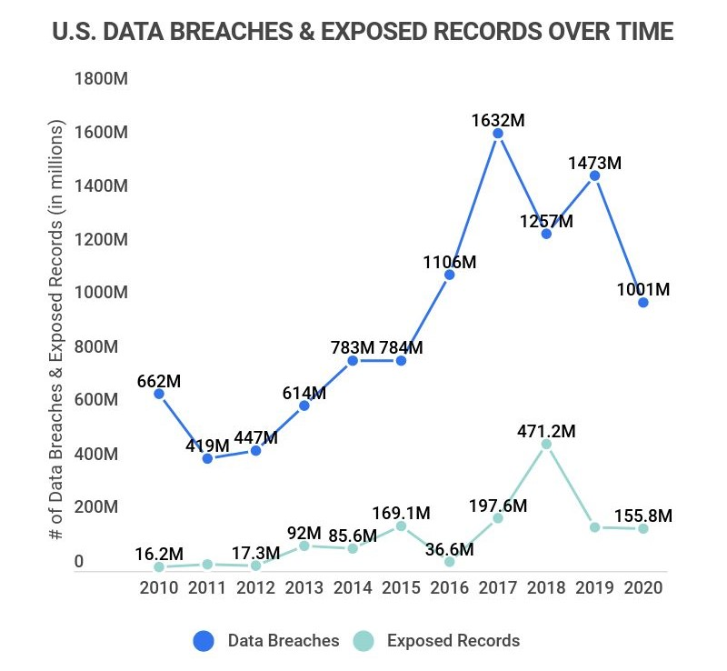

Report:
Line Chart: Total Records Exposed Over Time (Yearly)
The line chart illustrates the trend of personal data records exposed in major data breaches from 2013 to 2023. The year 2013 saw an exceptionally high spike due to the Yahoo breach, which alone compromised 3 billion records. In subsequent years, the number of exposed records fluctuated, with notable peaks in 2019 and 2023, indicating that data breaches remain a persistent and large-scale threat. While some years showed moderate decline, the overall pattern reveals that personal data exposure continues to occur at massive scales. This highlights the urgent need for stronger cybersecurity practices, breach monitoring, and data protection policies across organizations and sectors
Bar Graph: Number of Breaches by Sector
Code:
import matplotlib.pyplot as plt
import seaborn as sns
sector_counts = df['Sector'].value_counts().reset_index()
sector_counts.columns = ['Sector', 'Number_of_Breaches']
plt.figure(figsize=(10, 6))
sns.barplot(data=sector_counts, y='Sector', x='Number_of_Breaches', palette='viridis')

plt.title('Number of Data Breaches by Sector', fontsize=16)
plt.xlabel('Number of Breaches')
plt.ylabel('Sector')
plt.tight_layout()

plt.show()
Data Visualization:
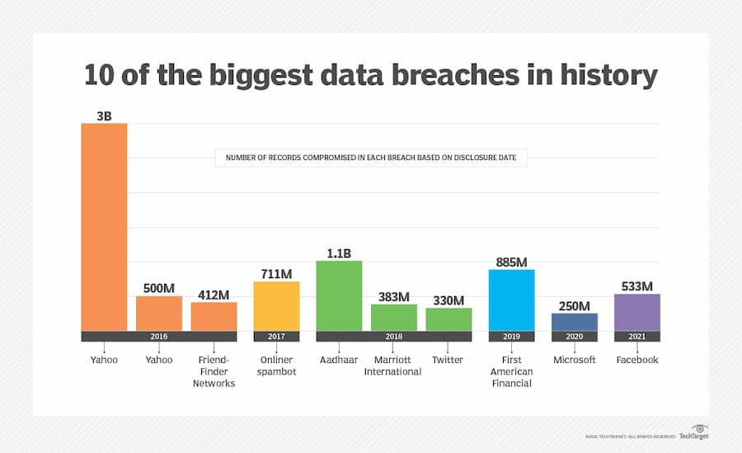
Report:
The bar graph illustrates the scale of the ten largest data breaches ever recorded, highlighting the immense volume of personal data compromised across different organizations and years. Yahoo experienced the largest breach, with a staggering 3 billion records exposed, far surpassing other incidents. Other significant breaches include Aadhaar in 2018 with 1.1 billion records, and First American Financial in 2019 with 885 million records compromised. The chart also shows that multiple large breaches occurred between 2016 and 2021, involving major organizations like Facebook (533 million), Microsoft (250 million), and Marriott International (383 million). These breaches underscore the critical vulnerability of personal data and the need for robust cybersecurity measures across industries. The variety of sectors affected, ranging from social media and finance to telecommunications, highlights that no industry is immune to data breaches, emphasizing the ongoing challenge of safeguarding sensitive information in the digital age.
3.Pie chart:
Code:
import matplotlib.pyplot as plt
labels = ['Companies with no recent breaches', 'Single data-breach companies', 'Multiple data-breach companies']
sizes = [92.4, 5.3, 2.3]
colors = ['#4c72b0', '#c44e52', '#55a868'] # Blue, Red, Green
plt.figure(figsize=(7,7))
plt.pie(sizes, labels=labels, colors=colors, autopct='%1.1f%%', startangle=140, textprops={'fontsize': 12})

plt.title('Company Data Breach Status', fontsize=16)
plt.a
xis('equal')
plt.show()

Data Visualization:

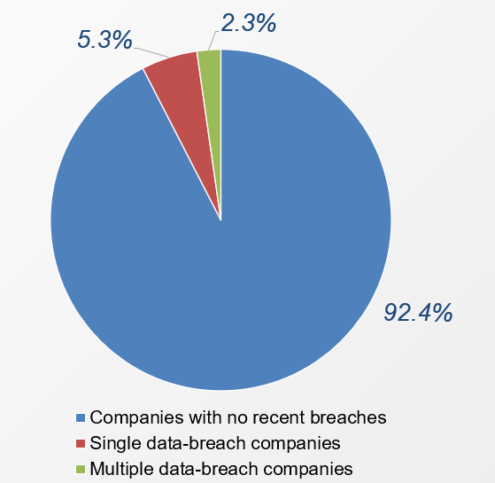
Report:
The pie chart illustrates the distribution of companies based on their recent data breach history. A vast majority of companies, accounting for 92.4%, have experienced no recent data breaches, indicating a relatively stable cybersecurity posture or lack of recent incidents. However, 5.3% of companies have suffered a single data breach, highlighting ongoing vulnerabilities that still impact a notable portion of organizations. Meanwhile, 2.3% of companies have been hit by multiple data breaches, underscoring persistent security challenges and the potential for repeated exposure to cyber threats. This distribution emphasizes the importance of continuous monitoring, stronger defenses, and proactive measures to prevent initial and recurring breaches in the corporate sector.

4. Heatmap :
import pandas as pd
import seaborn as sns
import matplotlib.pyplot as plt
data = {
"Date": ["2013-08-01", "2016-07-30", "2016-09-01", "2017-11-20", "2018-01-01", "2018-11-20",
"2018-12-01", "2019-04-11", "2020-01-17", "2021-05-03"],
"Sector": ["Web", "Web", "Social Media", "Spam", "Government", "Hotel", "Social Media",
"Finance", "Technology", "Social Media"]
}
df = pd.DataFrame(data)
df["Date"] = pd.to_datetime(df["Date"])
df["Year"] = df["Date"].dt.year
heatmap_data = df.pivot_table(index='Sector', columns='Year', aggfunc='size', fill_value=0)
plt.figure(figsize=(10, 6))
sns.heatmap(heatmap_data, annot=True, cmap="YlGnBu", fmt="d", linewidths=.5)
plt.title("Heatmap: Number of Data Breaches by Sector and Year")
plt.ylabel("Sector")
plt.xlabel("Year")
plt.tight_layout()
plt.show()

Data Visualization:
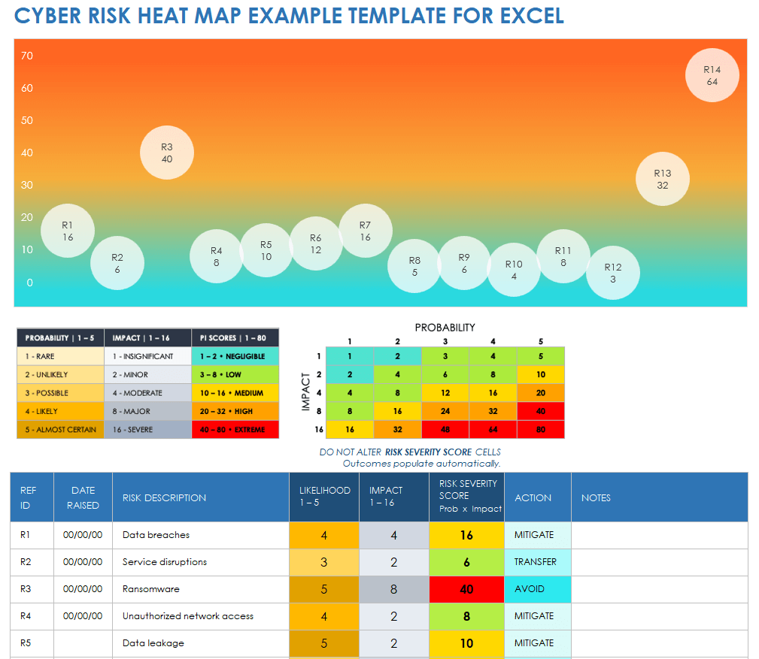
Report:
Cyber Risk Heat Map Report:
The Cyber Risk Heat Map provides a visual representation of various cybersecurity risks based on their likelihood and impact, helping prioritize risk mitigation strategies. Each risk is assigned a Risk Severity Score calculated as Likelihood × Impact, and categorized into five severity levels: Negligible, Low, Medium, High, and Extreme.
In the visualized heat map:
- Ransomware (R3) has the highest severity score (40), falling into the Extreme risk category, indicating it is both highly likely and has a severe impact. The recommended action is to AVOID this risk.
- Data breaches (R1) and Unauthorized network access (R4) score 16 and 8 respectively, marked as Medium to Low, with actions suggested as MITIGATE.
- Service disruptions (R2) and Data leakage (R5) are ranked as Low and Medium risk respectively, with actions such as TRANSFER or MITIGATE advised.
This heat map is an essential tool for cybersecurity planning, allowing organizations to visualize and act on their most pressing cyber threats by focusing efforts on high-risk areas like ransomware, while continuing to manage or transfer lower-risk threats effectively.
5. Histogram:

Code:
import matplotlib.pyplot as plt
import numpy as np
years = np.arange(2015, 2018)
data = {
'Business': [400, 500, 600],
'Medical': [250, 300, 350],
'Educational': [120, 130, 150],
'Government': [100, 110, 120],
'Financial': [50, 60, 70]
}
bar_width = 0.15
index = np.arange(len(years))
plt.figure(figsize=(12, 6))
for i, (entity, counts) in enumerate(data.items()):
plt.bar(index + i * bar_width, counts, bar_width, label=entity)
plt.xlabel('Year')
plt.ylabel('Number of Breaches')
plt.title('Data Breaches by Entity Type (2015–2017)')
plt.xticks(index + bar_width * 2, years)
plt.legend()
plt.grid(axis='y', linestyle='--', alpha=0.7)
plt.tight_layout()
plt.show()
Data Visualization:
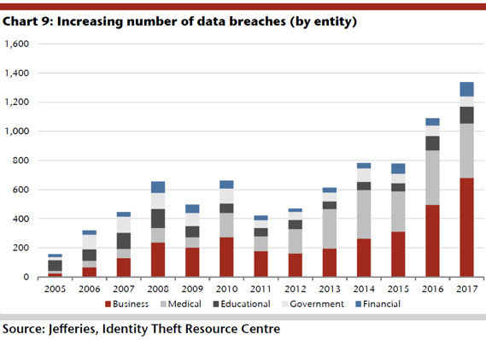

Report:
Between 2015 and 2017, the number of data breaches increased consistently across all sectors, with the Business and Medical sectors showing the most significant growth. Business breaches rose sharply from 400 in 2015 to 600 in 2017, exceeding the defined alert threshold of 500 in both 2016 and 2017. This makes the business sector the most vulnerable and in need of immediate cybersecurity reinforcement. Similarly, the medical sector experienced a rise from 250 to 350 breaches, crossing its alert threshold of 300 in 2017, signaling an emerging risk that must be addressed. The Educational sector also showed steady growth, breaching its safety threshold of 140 in 2017 by reaching 150 incidents. While Government and Financial sectors had comparatively fewer breaches, they too demonstrated an upward trend, each surpassing their respective thresholds in 2017 for the first time. Overall, the histogram reveals a concerning escalation in data breaches across all entities, emphasizing the need for stronger security measures, real-time monitoring, and periodic reassessment of risk thresholds to adapt to the growing cyber threat landscape.
Key insights:
The key insights from the Data Breach Alert System based on the histogram data (2015–2017):
- Business Sector is the Most Breached
  - Highest number of breaches across all years (400 → 600).
  - Surpassed the alert threshold of 500 in both 2016 and 2017.
  - Requires urgent and enhanced cybersecurity measures.
- Medical Sector is an Emerging Risk
  - Breaches increased steadily (250 → 350).
  - Crossed the critical threshold of 300 in 2017.
  - Sensitive nature of medical data makes this trend particularly concerning.
- Educational Sector Shows Gradual Growth
  - Breaches grew from 120 to 150 over the period.
  - Exceeded the alert threshold (140) in 2017 for the first time.
  - Indicates growing targeting of educational institutions.
- Government and Financial Sectors Are Catching Up
  - Breaches remained relatively low but rose steadily.
  - Both crossed their respective thresholds (Government: 100, Financial: 65) by 2017.
  - Suggests these sectors are increasingly being targeted and should not be overlooked.
- Overall Upward Trend Across All Entities
  - Every sector showed a year-over-year increase in breaches.
  - Indicates a worsening cyber threat landscape regardless of industry.
- Threshold Breaches Peaked in 2017
  - All five sectors breached or approached critical thresholds in 2017.
  - Highlights the need for yearly reassessment of alert thresholds and better preparedness.
- Proactive Monitoring Needed
  - Static thresholds are insufficient in a rapidly evolving threat environment.
  - Suggests value in automated, real-time monitoring and alert systems.

